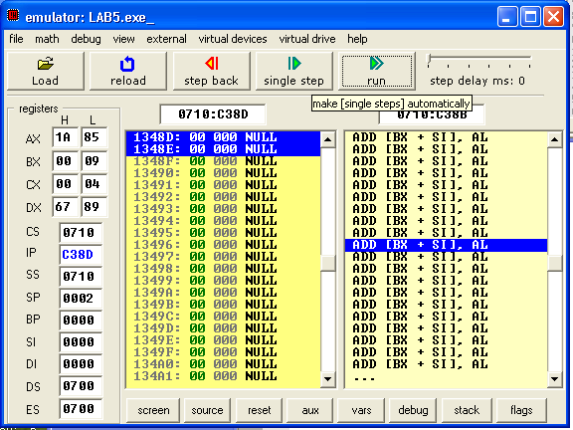
BCD TO BINARY SUBROUTINE

